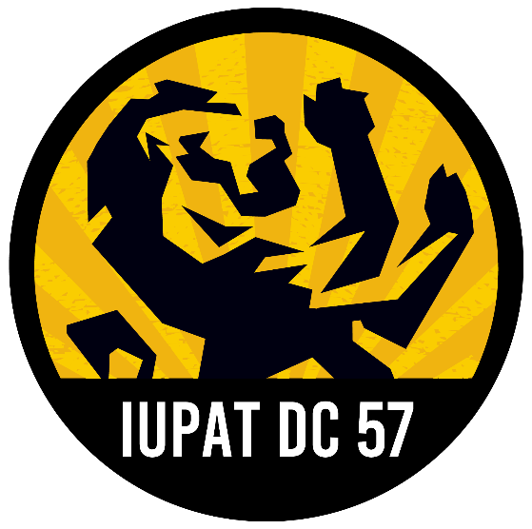
International Union of Painters and Allied Trades
District Council 57

2024 Pennsylvania Candidate Survey

Please complete this form and email to Aaron Joseph (ajoseph@iupatdc57.org). You may direct any questions to Aaron (412) 912-6755 or Political Director Joe Hughes (412) 396-9391.

Candidate Information

- Candidate Name

- Office Sought

- Political Party

- Campaign PAC Name

- Campaign Mailing Address

- Campaign Contact Name and Position

- Campaign Contact Email

- Campaign Contact Cell Phone
Please provide full answers to the questions below. DC 57 endorses candidates independently from the International Union of Painters and Allied Trades and the PA AFL-CIO. The answers in this form will be used to help inform DC 57 about candidates in 2024 races and filling out the questionnaire does not guarantee an endorsement from DC 57. These answers will be used for internal purposes only unless the candidate or the candidate’s campaign consents to having their answers published on DC 57’s website (www.iupatdc57.org).

☐ I would like my answers to the questions below to be published on IUPAT DC 57’s website.

GENERAL

- Why are you seeking this position?

- What are your campaign’s top themes/issues?

- Provide a brief overview of your campaign’s field operation and your media strategy. How will this incorporate organized labor?

- How has your campaign been funded to this point? How will your campaign reach its fundraising goals?

- Have you held any elected offices before? Do you have any other experience working in federal, state, and/or local government?

- If you have run for elected office before, please list all prior campaigns.

- Have you ever belonged to a labor union? What does being part of a union mean to you?

- Do you have any prior professional experience with organized labor?

- Please list any labor endorsements and/or other relevant endorsements you’ve already earned.

LABOR POLICY

- If (re)elected, will you support the Pennsylvania constitutional amendment to ban right to work and vote against any and all efforts to make Pennsylvania a right to work state?

- If (re)elected, what steps will you take toward eliminating wage theft and fostering an environment of greater worker protections?

- Would you support legislation that would prevent worker misclassification? What does effective anti-worker misclassification legislation look like to you? Do you think that current penalties under Act 72 are too lenient, appropriate, or too harsh?

- Would you support legislation that requires all publicly funded construction work to be performed by a minimum of 50% Pennsylvania workers (or 50% of workers hired out of a PA-based hiring hall)?

- Do you support local hiring ordinances that go beyond the scope of the legislation described in the prior question?

- Prevailing wage is a protection that ensures a livable wage is paid to workers in construction. Prevailing wage is not a “union” wage, it is determined by local surveys of wages paid in a given area regardless of union membership. In Pennsylvania, all public projects that are over $25,000 are required to pay workers on a project the prevailing wage. Prevailing wages on public projects ensure that skilled workers are used, and public goods are built using labor that is not hired in a race to the bottom. Additionally, studies show that the use of skilled labor helps make sure that projects are done on time and within budget. Legislation is introduced at times to make changes to Pennsylvania’s prevailing wage law, which can undermine its effectiveness in maintaining a fair wage. Do you support the Pennsylvania Prevailing Wage law and oppose any efforts to raise the funding requirement or make exceptions to the law?

- How do you see the role of statewide or local responsible contractor ordinances (RCOs)? Have you supported any statewide or local RCOs in the past?

- If (re)elected, how would you use your office to reintroduce/reinforce trades education in PA’s school?

- Do you support E-Verify?

- Do you support the use of project labor agreements (PLAs) on construction projects?

- If (re)elected, what would be your general and/or labor priorities over the course of your term in office? What sort of help would you need from DC 57 and the building trades to help accomplish those priorities?

PUBLIC ADVOCACY

- Tell us about a time you publicly supported a fight for basic workers’ rights. If elected, how would you use your position to draw attention to workers’ issues?

- Do you plan on using your campaign to amplify workers’ voices? If so, how?

- How would you call attention to the issues that perpetuate the underground economy? Exploitation of undocumented workers, wage theft, misclassification, unfair labor practices, etc.

Is there anything else you would like us to know as we consider who to support in your race? Please add anything you’d like below.

